Osmosis Investigation

State the aim of this investigation:

To investigate the effect of concentration of salt solution on the mass of plant tissue.

Apparatus:

- potato
- cork borer
- a 10 cm³ measuring cylinder
- labels
- three boiling tubes
- test tube rack
- paper towels
- sharp knife or scalpel
- white tile
- a range of salt solutions (1.0M - 0.25 M)
- distilled water
- a balance

Method:
- Use a cork borer to cut five potato cylinders of equal diameter
- Use the knife or scalpel to ensure the cylinders are the same length
- Measure and record the mass of each cylinder
- Measure 10 cm³ of 1.0 M salt solution and pour into a boiling tube
- Repeat Step 4 for three different concentrations of salt solutions, ensuring that the boiling tubes are labelled with their concentrations
- Repeat step 4 with distilled water and pour into the fifth boiling tube
- Add one potato cylinder to each boiling tube
- Record the initial masses of the potato cylinders in the table below
- Leave the boiling tube for 30 minutes – 1 hour in the test tube rack
- Remove the cylinders from the boiling tubes and blot dry with paper towel
- Measure the new mass of each cylinder and record the new masses in the table
- Calculate the change in mass and the percentage change in mass for each cylinder
- Plot a graph of your results with ‘change in mass (g)’ on the y-axis against ‘concentration of salt solution’ on the x-axis

Results:

 | 1.0 M salt solution | _______salt solution | _______salt solution | ______salt solution | Distilled  water
Initial mass (g)
Final mass (g)
Change in
mass (g)
Percentage
change in
mass

Conclusion:

1.0 M salt solution will cause the potato to decrease in mass as water moves out of the potato. Distilled water will cause the potato to increase in mass as water moves into the potato.

Questions:

- State the independent variable in this experiment.

Concentration of salt solution

- State the dependent variable in this experiment.

Change in mass of potato

- State the control variables in this experiment.

Starting mass/size of potato, volume of salt solution/water, time boiling tubes left for

- Why are the cylinders blotted dry?

To absorb excess water/salt solution so it does not affect the final mass of the potato cylinder

- Why is percentage change calculated?

If the starting mass of potato was not identical it allows a comparison to be made.

Concentration of salt solution (mol/dm³) | Percentage change in mass (%)
0.0 | + 3.5
0.2 | + 2
0.4 | + 0.75
0.6 | - 1
0.8 | -2.5
- A pupil followed the same method as above using a piece of carrot instead of potato. They recorded an increase in mass as a positive percentage change and a decrease in mass as a negative percentage change. Their results are seen in the table below.

- Draw a graph of the pupils results on the graph paper below. You must:

• Choose a suitable scale and label for the y-axis.

• Plot the results.

• Draw a line of best fit
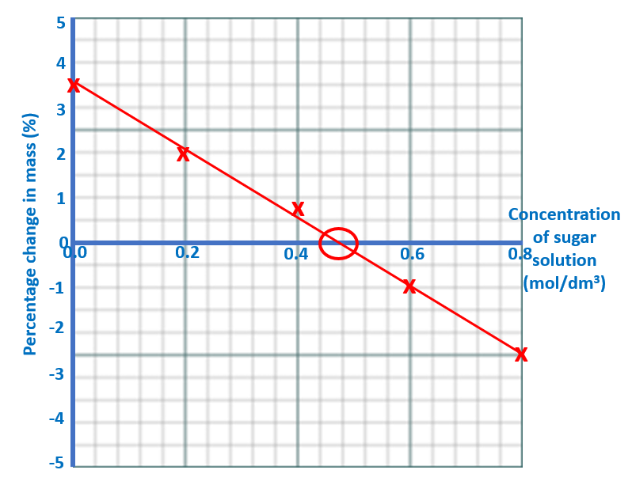
salt

- Use your graph to estimate the concentration of salt solution inside the carrot cells.
Depending on LOBF. Should be approximately 0.48 mol/dm³

